Origami Fortune Teller
More Kinder Crafts
A simple-to-make origami fortune teller (also called a cootie catcher).
Supplies needed:
- Construction paper  - Scissors  - Pen or pencil | 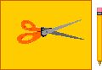

 | Start by making a square piece of paper. To start making the square, fold one corner of a piece of paper over to the adjacent side.

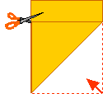 | To finish making the square, cut off the small rectangle, forming a square (which is already folded into a triangle).

 | Fold the two opposite ends of the triangle together, forming a smaller triangle.

 | Open the paper up (unfolding all the folds).

 | Fold a corner into the central point. Repeat with the opposite corner.  Repeat with the other 2 corners. You'll end up with a square. | 

 | Flip the paper over.  Fold a corner over to the center. Repeat with the opposite corner.  Fold over the 2 remaining corners. You'll end up with a smaller square. | 

Fold the square in half. Unfold and fold in half the other way.

 | Unfold and pull the four ends together, making a diamond-like shape. Pick up each of the four square flaps, and put your fingers inside. You will be able to move the four parts around.

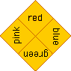 | Write any four colours on the four flaps.  Flip it over, and write 8 numbers on the triangular flaps. | 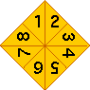

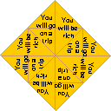 | Write 8 fortunes inside the flaps (underneath the numbers). Some examples of fortunes include:  - You will get an "A" on a test.  - You will be rich.  - Good fortune will be yours.  - You will have many friends.  - Do a good deed today.  - Someone will call you today.  - You will go to a party soon.  - Be careful on Tuesday.  - You will have very good luck today.

 | You can now be a fortune teller. Have a person choose one of the four colors. Spell that color out, while moving the fortune teller in and out.  Then have the person choose one of the numbers that is showing. Move the fortune teller in and out the right number of times.  When you finish, have the person choose one of the four visible numbers. Open up the flap they choose, and read their fortune.

